Application for Certificate in Science Communication

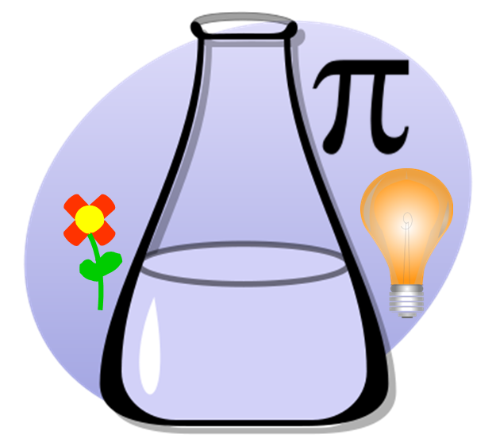

21st Century Scientists Working Group (http://21centurysci.com/)
Center for Innovation in Teaching and Learning (citl.illinois.edu)
Contact Information

Name:
Home Department:
Email Address:
Degree Sought (*): MS / PhD
Date of Completion:

Certificate Checklist

Applicants should contact the 21st Century Scientists Working Group prior to beginning work on the certificate (21centurysci@gmail.com). All items on this checklist must be completed and documented in this application. It is the
applicant’s responsibility to keep track of all dates and signatures for verification of requirements.

(*)This certificate is designed for graduate students currently enrolled at the University of Illinois at Urbana-Champaign, but interested others should contact us.

Requirements

- 21st Century Scientists Working Group journal clubs or talks.
- Attend science communication-themed workshops or seminars.
- Read, watch, or listen to an experienced science communicator and complete a report.
- Complete a public engagement project and submit a report on it.
- Complete a reflective piece on your philosophy of science communication and public engagement.

1. Attend three 21st Century Scientists Working Group journal clubs or talks, and present at one 21st Century Scientists Working Group journal club.

Dates attended (three minimum):

Date(s) presented (one minimum):

Working Group journal clubs are typically offered once monthly and last one hour, including discussion; organized talks are offered several times per semester and also last about one hour. See the 21st Century Scientists Working Group website (21centurysci.com) for meeting times and location.

2. Attend a minimum of 10 hours of science communication-themed workshops or seminars.

This must include attending the 21st Century Scientist annual workshop. You may select from the following or request to have another workshop accepted. For on campus events, obtain a signature to verify your presence. For off campus events, submit a brief description of the event and your reaction to it (for example, one paragraph of text; your storified live tweets of the event; or other media).
- 21st Century Scientist weekly meetings
- ComSciCon (comscicon.com, local or national)
- AAAS science communication workshop
- science communication track at professional meeting (with prior approval)

Events attended (descriptions and dates):

3. Read, watch, or listen to an experienced science communicator and complete a report.

Your report should describe the content, what the communicator did well, what could have been improved upon (if anything), and what you learned from the experience.

- Read a science themed book intended for a lay audience
- Read 3 science blog posts by a single author or on the same topic
- Read 3 related science themed magazine articles (by the same author, from the same magazine, or covering similar concepts)
- Watch a live science presentation intended for a lay audience
- Attend a live public engagement event, such as a children's museum science presentation
- Watch a single long-form or 3 short-form science themed videos intended for a lay audience, preferably with a unifying theme (e.g., all on related topics) or a single format (e.g., all TED or all TED-Ed videos).

Please attach report to your application. (See last page for details on report requirements.)
4. Complete at least one public engagement project and complete a report on your experience (what you did and what you learned from it).

- Maintain a blog/vlog/podcast covering science for a lay audience (minimum 5 posts)
- Publish a science story in a popular press publication
- Create a related series of videos on science for a lay audience and publish them (e.g. on YouTube) (minimum 5 videos)
- Participate in planning and implementing a public science event, such as in a school classroom, at a farmer's market, or in a museum (contact 21st Century Scientists Working Group for assistance in identifying groups currently running such events)
- Complete a science communication class at U of I (list of classes attached, or you may petition to have a new class accepted)
- Complete a one-semester or longer SciComm internship (contact 21st Century Science Working Group for assistance in setting one up)
- Present on science to a live lay audience (minimum 20 minutes)
- Other project, with prior approval

Please attach report to your application. (See last page for details on report requirements.)
5. Complete a reflective piece on your philosophy of science communication and public engagement.

Possible topics that you might cover include: What does science communication mean to you? Why is science communication important? What is an audience, or, what is your audience? How do you prefer to engage with your audience, and how do you determine whether that engagement has been successful? Ideally, this report will include how your understanding changed over time during the course of completing the requirements.

Please attach report to your application. (See last page for details on report requirements.)

Reflective report guidelines

A reflective report may take any format you prefer, including an essay (about 2 pages), video (about 5 minutes), infographic, series of photographs, or comic (sequential art). In the case of the two requirements, observation of an experienced communicator and completion of a public engagement project, the goal of the report is a) to describe the experience and b) to reflect on what you learned from the experience.
Attendance sheet
Please print and fill out (signatures should be obtained at each event attended), then attach scanned copy to your certificate application.

Attendance at 21sci journal clubs or talks

You should attend at least three 21sci journal clubs or talks. Additionally, you should present at at least one 21sci journal club.

Date | Talk/paper title | Presented? | Signature

Attendance at science communication-themed workshops

You should attend at 10 hours of science communication-themed workshops or seminars. This must include the 21sci annual spring workshop.

Date | Workshop | Hours | Signature

